**ROBOL FUNCTIONAL REQUIREMENTS**

**SYSTEM OVERVIEW**

* Robo-L is a product developed for kids to learn early programming at the age of 7+ to 12 years.
* Robo-L has 2 functional components as SLATE and BOT.
* SLATE: Used to Insert coins, scan and send commands to BOT
* BOT: Used to receive the commands from SLATE and execute those commands as commanded.

**BOT FUNCTIONAL DIAGRAM**

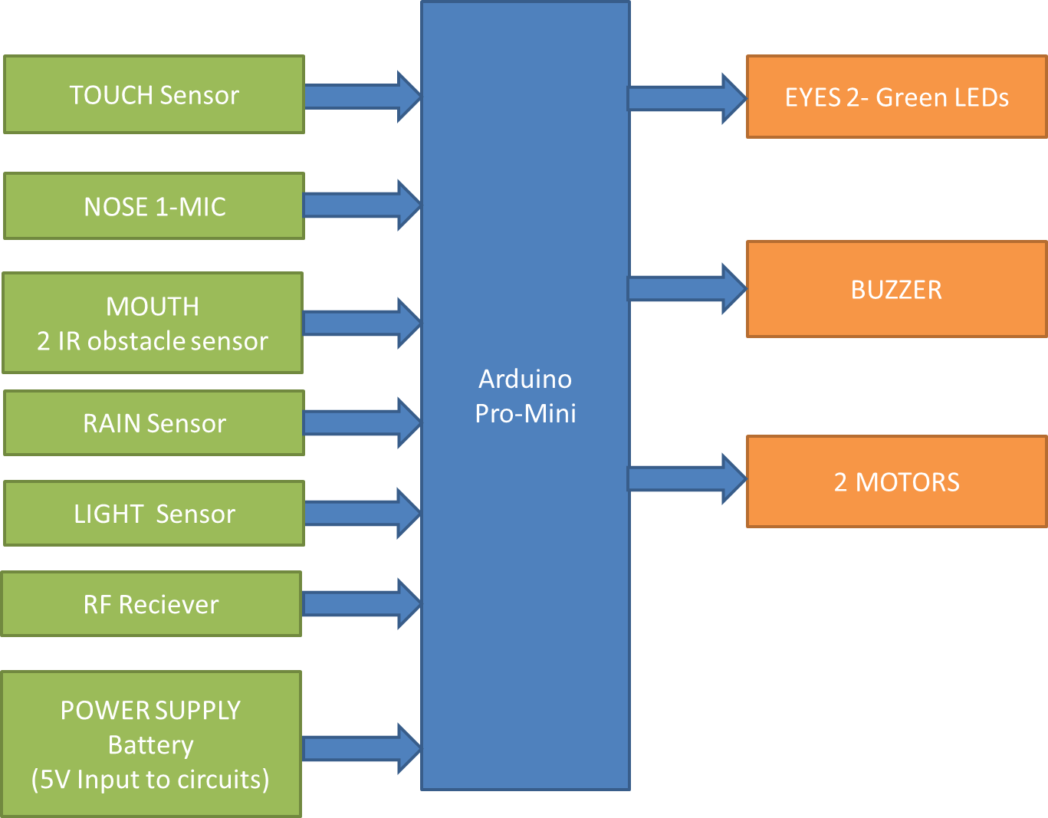

**Hardware required for BOT circuit:**

1. **ARDUNIO CONTROLLER:** Ardunio consists of both a physical programmable circuit board (often referred to as a [microcontroller](http://en.wikipedia.org/wiki/Microcontroller)) and a piece of [software](http://arduino.cc/en/Main/Software), or IDE (Integrated Development Environment) that runs on your computer, used to write and upload computer code to the physical board. The Ardunio does not need a separate piece of hardware in order to load new code onto the board -- you can simply use a USB cable. Additionally, the Ardunio IDE uses a simplified version of C++, making it easier to learn to program.

 Ardunio Uno features 14 digital input/output pins (six of which can be used as PWM outputs), six analog inputs, and a 16MHz quartz crystal. Uno also includes a USB connection, a power jack, an In-Circuit Serial Programming (ICSP) header, and a reset button

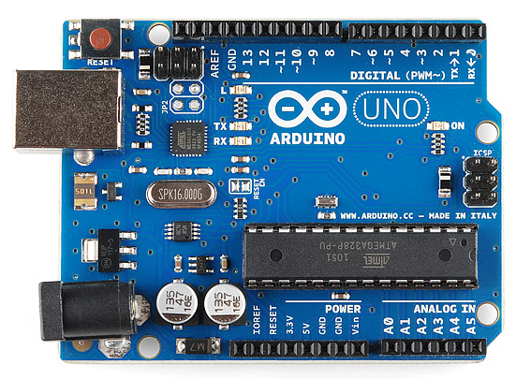

**Ardunio controller board**

1. **MOTOR DRIVING CIRCUIT:** Motor Driver circuits are current amplifiers. They act as a bridge between the controller and the motor in a motor drive. Motor drivers are made up of discrete components that are integrated inside an integrated circuit (IC).

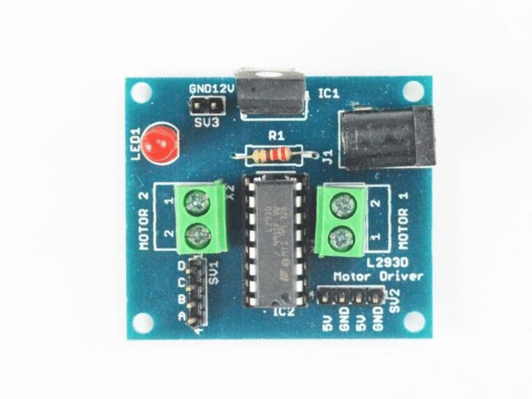

**Motor driving circuit**

1. **LDO voltage Regulators**: An LDO (low dropout) regulator is a linear regulator that can operate at a very low potential difference between the input and output voltage. A low-dropout regulator's (LDO) nature is to regulate a voltage by turning excess power into heat.

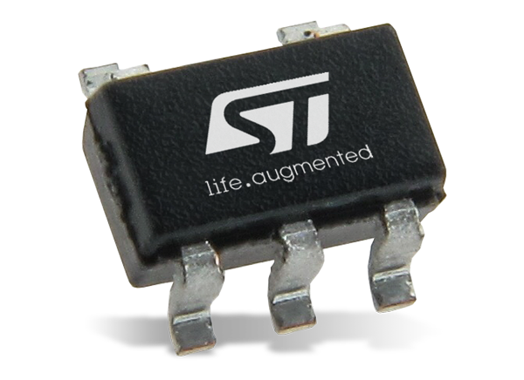

**LDO VOLTAGE REGULATOR**

1. **TOUCH SENSOR:** A touch sensor is a type of equipment that captures and records physical touch or embrace on a device and/or object. Touch sensors work similar to a switch. When they are subjected to touch, pressure or force they get activated and act as a closed switch. When the pressure or contact is removed they act as an open switch.. These are simple to design, low cost and are produced in large scale

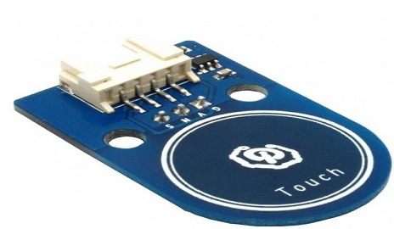

**TOUCH SENSOR**

1. **RAIN SENSOR:** A rain sensor is one kind of switching device which is used to detect the rainfall. It works like [a switch](https://www.elprocus.com/sound-activated-switch/) and the working principle of this sensor is, whenever there is rain, the switch will be normally closed. The rain sensors are based on Total Internal Reflection.

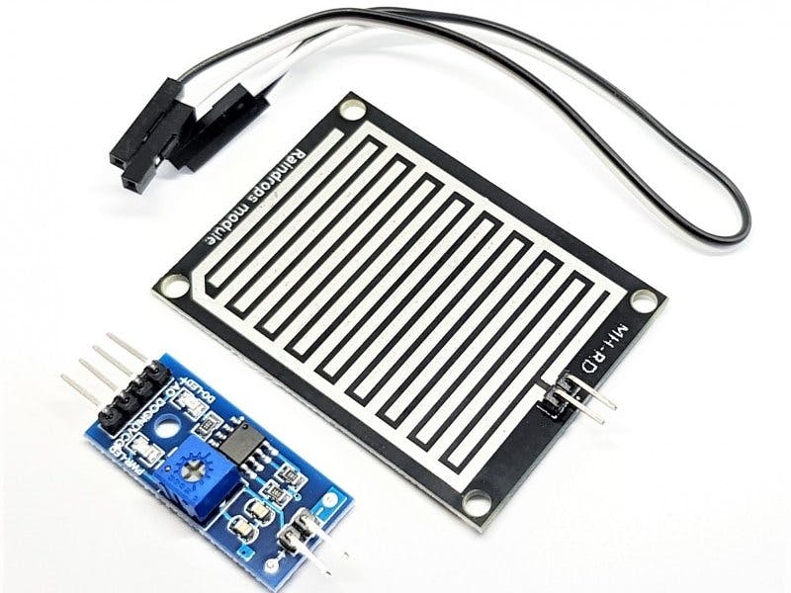

**RAIN SENSOR**

1. **SOUND DETECT SENSOR:** A sound sensor is defined as a module that detects sound waves through its intensity and converting it to electrical signals. This sensor employs a microphone to provide input to buffer, peak detector and an amplifier. This sensor notices a sound, & processes an o/p voltage signal to a microcontroller. After that, it executes required processing.

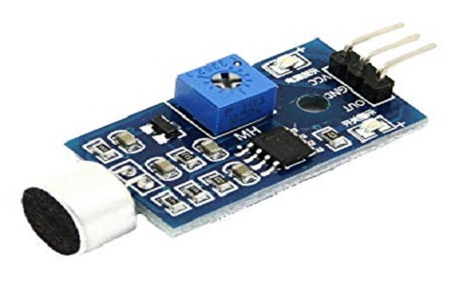

**SOUND DETECTION SENSOR**

1. **OBJECT DETECT SENSOR**: IR sensor is an electronic device that emits the light in order to sense some object of the surroundings. An IR sensor can measure the heat of an object as well as detects the motion. Infrared sensors emit infrared light and once this light hits an object, it is reflected back to the sensor. Depending on the strength of the reflected light, the sensor will know how far or close an object is. The stronger the reflected signal, the closer the object. The weaker the signal, the farther the object is.

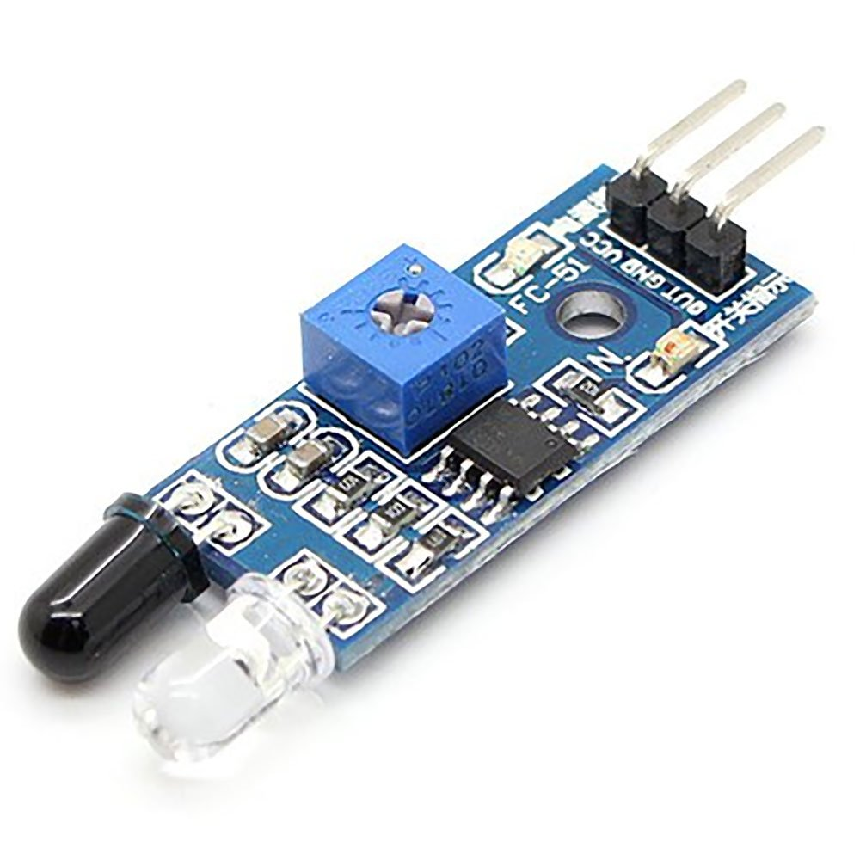

**OBJECT DETECT SENSOR**

1. **IR RECIEVER CIRCUIT:** IR Receiver Circuit is used to receive infrared signal from infrared transmission. Typical IC used is LM 358.IR Receiver Circuit is used to receive infrared signal from infrared transmission. Typical IC used is LM 358. It can receive infrared signal within 10 m. It operating voltage is 3.3v – 5v. The output signal compatible with TTL level 5v. A remote control patterns a flash of invisible light which is turned into an instruction and is received by the receiver module.

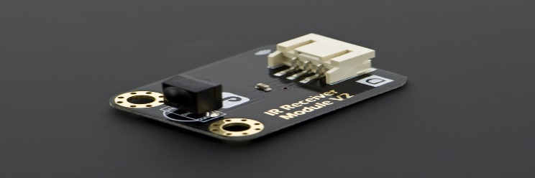

**IR RECIEVER CIRCUIT**

1. **LDR SENSOR:** A photo resistor or light-dependent resistor (LDR) or photocell is a light-controlled variable resistor. A Light Dependent Resistor (LDR) works on the principle that its resistance. The resistance of a photo resistor decreases with increasing incident light intensity In other words, it exhibits photoconductivity.

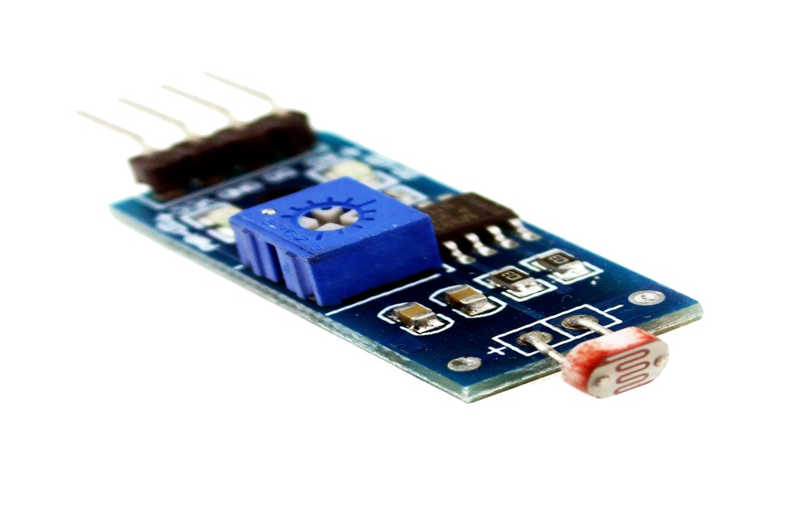

**LDR SENSOR**

1. **RF RECIEVER:** An RF receiver module receives the modulated RF signal, and [demodulates](https://en.wikipedia.org/wiki/Demodulation) it. There are two types of RF receiver modules: [super heterodyne receivers](https://en.wikipedia.org/wiki/Superheterodyne_receiver) and super regenerative. RF system communication use 433MHz frequency.

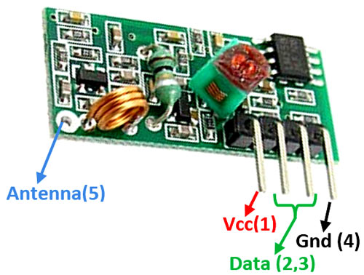

**RF RECIEVER**

**11) EYE LED:** A Light Emitting Diode (LED) is a semiconductor device, which can emit light when an electric current passes through it. To do this, holes from p-type semiconductors recombine with electrons from n-type semiconductors to produce light. This LED is used as eyes for the BOT.

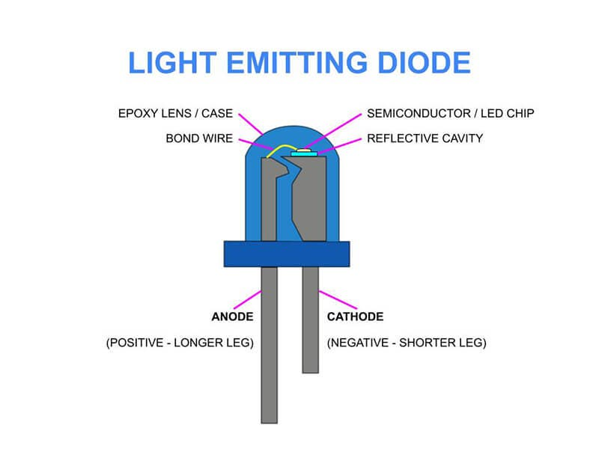

1. **DEBUGGING LED:** Debugging is the process of finding and resolving defects or problems within a robot that prevents correct operation of robot or a system. To indicate the bug or issue in the robot, LED starts indication until the bug solved**.**
2. **BUZZER:** An audio signaling device like a beeper or buzzer may be electromechanical or [piezoelectric](https://www.elprocus.com/what-is-a-piezoelectric-material-working/) or mechanical type. The main function of this is to convert the signal from audio to sound. Generally, it is powered through DC voltage and used in timers, alarm devices, printers, alarms, computers, etc. Based on the various designs, it can generate different sounds like alarm, music, bell & siren.

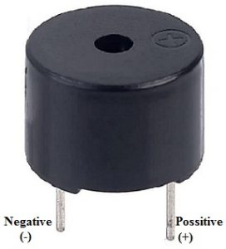

**BUZZER**